Menu Details 2

Buttons 2

Level Details 3

V1 3

V2 3

V3 3

V4 3

Art Requirements 4

Limitations 4

Menu 4

Game 4

Sound Requirements 5

Limitations 5

Menu 5

Game 5

HARDWARE Requirements 6

Desktop 6

Android 6

# Menu Details

## Buttons

For the Menu we will have the following buttons:

* **Start**

When the user click the start button the user will allow to start a new game. The start button we be made in Photoshop for the design details please look at Design Document.

* **Exit**

The exit function will close the application and clean up the objects that we created in the game or menu state after the objects has been clean the application we close immediately. The start button we be made in Photoshop for the design details please look at Design Document.

# Level Details

## V1

Basic Design of the game

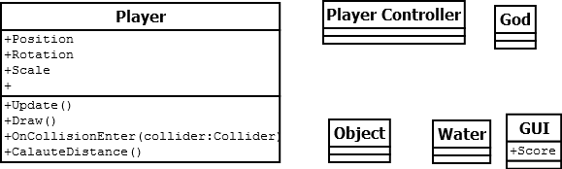

# Art Requirements

## Limitations

OBJ, FBX only

## Menu

Art COMPONENT in Menu Are listed below

|  |
| --- |
| Start Button |
| Exit Button |
| Background |

## Game

Art COMPONENT in GAME are listed below

|  |
| --- |
| FISHES |
| Background(Water , RAIN , METERS THAT COUNT HOW FAR IT IS) |
| PLAYER |
|  |

# Sound Requirements

## Limitations

MP3, WAV only.

## Menu

SOUND COMPONENT in Menu Are listed below

|  |
| --- |
| Background music |
| Click Sound Effect |

## Game

SOUND COMPONENT in GAME are listed below

|  |
| --- |
| Background Music |
| Wind Blow Sound Effect |
| Characters been selected Sound Effect |
| Jumping On the Water Effect |
| Adding Score Sound effect |
| Picking Up Object |
| Throw FISH SOUND EFFECT |
| Start Game Sound Effect |

# HARDWARE Requirements

## Desktop

OS: Windows XP+, Mac OS X 10.7+, Ubuntu 10.10+, SteamOS+

Graphics card: DX9 (shader model 2.0) capabilities; generally everything made since 2004 should work.

CPU: SSE2 instruction set support.

Web player supports IE, Chrome, Firefox, Safari and others.

## Android

OS 2.3.1 or later; ARMv7 (Cortex) CPU or Atom CPU; OpenGL ES 2.0 or later.